Cost-Optimisation-Assignment-01

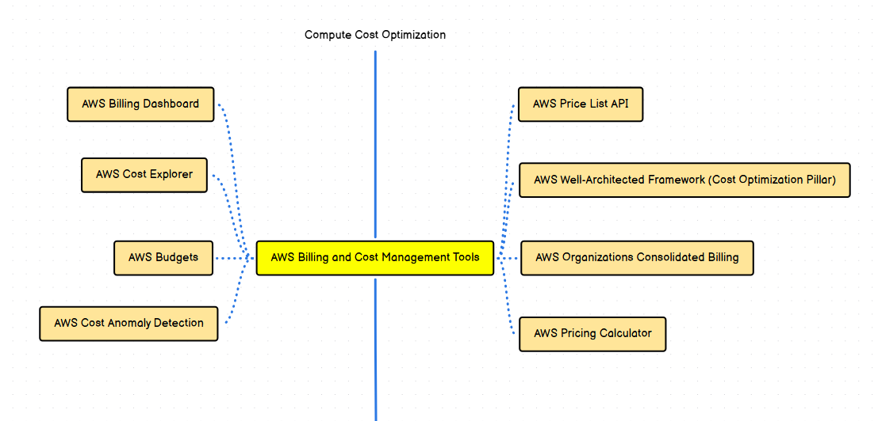
AWS Billing and Cost Management Tools
- Central suite to monitor, analyze, and control AWS costs.
- Helps track usage, forecast spending, and enforce budgets.
- AWS Billing Dashboard
- High-level view of current and past AWS charges.
- Shows month-to-date spend and service-wise breakdown.
- Useful for quick cost visibility.
- AWS Cost Explorer
- Interactive tool to analyse historical AWS usage and costs.
- Supports filtering by service, account, region, and tags.
- Helps identify cost trends and optimization opportunities.
- AWS Budgets
- Set cost or usage thresholds.
- Sends alerts when actual or forecasted spend exceeds limits.
- Used for proactive cost control.
- AWS Cost Anomaly Detection
- Uses ML to detect unusual spending patterns.
- Automatically alerts when abnormal cost spikes occur.
- Helps catch misconfigurations early.
- AWS Price List API
- Programmatic access to AWS service pricing.
- Used for building custom cost analysis or automation tools.
- Provides up-to-date pricing data.
- AWS Well-Architected Framework (Cost Optimization Pillar)
- Best practices to run workloads cost-effectively.
- Focuses on right-sizing, elasticity, and continuous optimization.
- Encourages regular cost reviews.
- AWS Organizations – Consolidated Billing
- Combines billing across multiple AWS accounts.
- Enables volume discounts and easier cost tracking.
- Supports cost allocation across teams/projects.
- AWS Pricing Calculator
- Estimates AWS service costs before deployment.
- Useful for architecture planning and cost forecasting.
- Helps compare pricing options.

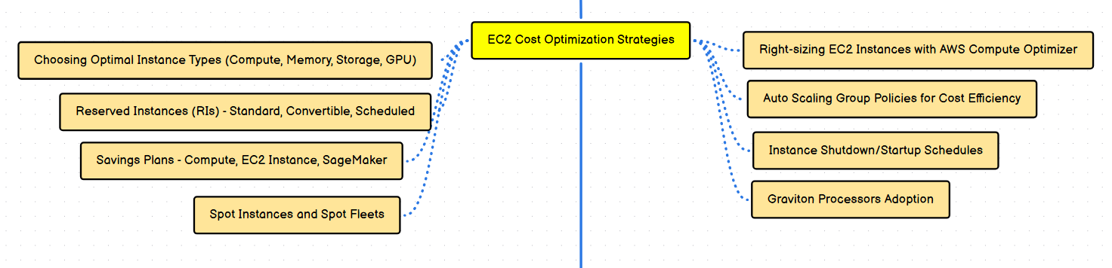
EC2 Cost Optimization Strategies
- Reduce EC2 cost by selecting the right instance, pricing model, and scaling strategy.
- Focus on matching capacity to actual workload demand.
- Choosing Optimal Instance Types (Compute, Memory, Storage, GPU)
- Select instance families based on workload needs.
- Avoid over-provisioning CPU or memory.
- Use GPU instances only when required.
- Reserved Instances (RIs)
- Standard RIs: Highest discount, fixed instance type.
- Convertible RIs: Lower discount, flexible instance exchange.
- Scheduled RIs: For predictable, time-bound workloads.
- Savings Plans
- Compute Savings Plan: Flexible across instance types and regions.
- EC2 Instance Savings Plan: Higher discount, less flexibility.
- SageMaker Savings Plan: For ML workloads.
- Spot Instances and Spot Fleets
- Use spare AWS capacity at up to 90% discount.
- Best for fault-tolerant and batch workloads.
- Spot Fleets manage diversified instance selection.
- Right-Sizing EC2 with AWS Compute Optimizer
- Uses historical metrics to recommend optimal instance sizes.
- Identifies underutilized or over-provisioned instances.
- Improves performance-to-cost ratio.
- Auto Scaling Group Policies for Cost Efficiency
- Scale out during high demand and scale in during low demand.
- Prevent paying for idle instances.
- Supports scheduled and dynamic scaling.
- Instance Shutdown / Startup Schedules
- Stop non-production instances during off-hours.
- Automate using Lambda or Instance Scheduler.
- Reduces unnecessary running costs.
- Graviton Processors Adoption
- ARM-based processors with better price-performance.
- Lower cost compared to x86 for compatible workloads.
- Ideal for Linux-based, cloud-native applications.

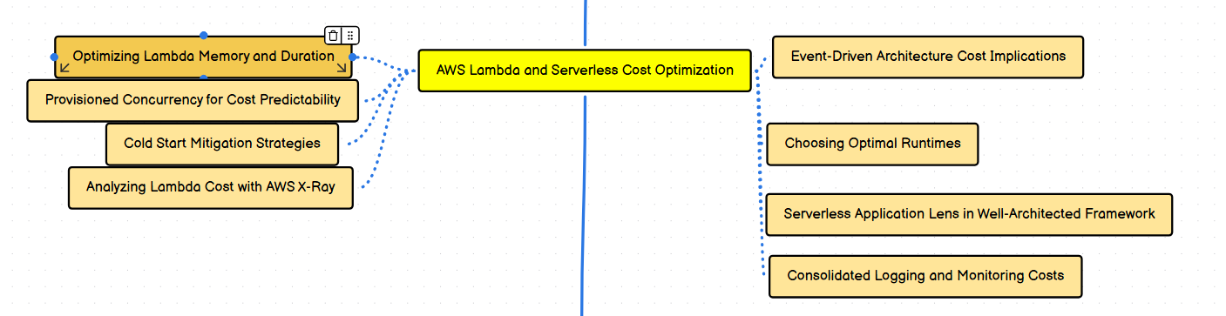
AWS Lambda and Serverless Cost Optimization
- Focuses on reducing execution time, memory usage, and unnecessary invocations.
- Cost = number of requests + execution duration + memory allocated.
  - Optimizing Lambda Memory and Duration
- Higher memory gives more CPU and can reduce execution time.
- Always benchmark different memory sizes to find the lowest total cost.
- Shorter execution time usually means lower cost.
  - Provisioned Concurrency for Cost Predictability
- Keeps Lambda functions warm and avoids cold starts.
- Useful for latency-sensitive workloads.
- Adds fixed cost, so best for steady or predictable traffic.
  - Cold Start Mitigation Strategies
- Use provisioned concurrency or keep functions small.
- Prefer lightweight runtimes and reduce package size.
- Avoid unnecessary dependencies and large initialization logic.
  - Analyzing Lambda Cost with AWS X-Ray
- Helps trace execution time and downstream service calls.
- Identifies slow components increasing duration costs.
- Useful for performance tuning and optimization.

  - Event-Driven Architecture Cost Implications
- Costs scale with events, not infrastructure.
- Excessive or noisy events can increase charges.
- Filtering events early reduces unnecessary executions.
  - Choosing Optimal Runtimes
- Some runtimes start faster and consume less memory.
- Prefer newer, efficient runtimes (e.g., Node.js, Python, Java with tuning).
- Runtime choice affects cold start and execution cost.
  - Serverless Application Lens (Well-Architected Framework)
- Provides best practices for cost, reliability, and performance.
- Encourages right-sizing, observability, and efficient design.
- Helps identify cost-optimization gaps.
  - Consolidated Logging and Monitoring Costs
- Logs and metrics can become expensive at scale.
- Set log retention policies.
- Log only what is necessary and avoid excessive debug logs.

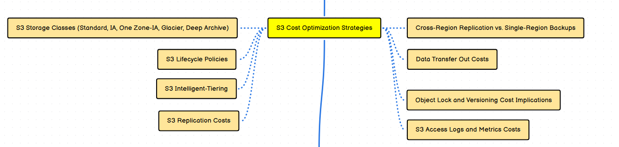
S3 Cost Optimization Strategies
- Optimize storage cost by selecting the right storage class and access pattern.
- Control lifecycle, replication, and data transfer costs.
  - S3 Storage Classes

- Standard: Frequent access, higher cost.
- Standard-IA: Infrequent access, lower storage, retrieval cost applies.
- One Zone-IA: Cheaper, stored in single AZ.
- Glacier: Archive, minutes–hours retrieval.
- Deep Archive: Lowest cost, hours–days retrieval.

  - S3 Lifecycle Policies
- Automatically move objects between storage classes.
- Expire or delete old data to reduce storage cost.
- Best for logs, backups, and archives.
  - S3 Intelligent-Tiering
- Automatically moves objects based on access patterns.
- Small monitoring fee, but avoids manual tiering.
- Ideal when access patterns are unpredictable.
  - S3 Replication Costs
- Includes PUT requests, storage in destination, and data transfer.
- Same-region replication cheaper than cross-region.
- Use only for compliance or DR needs.
  - Cross-Region Replication vs Single-Region Backups
- CRR improves disaster recovery but increases cost.
- Single-region backups are cheaper but less resilient.
- Choose based on RTO/RPO requirements.
  - Data Transfer Out Costs
- Inbound data is free, outbound is chargeable.
- Minimize cross-region and internet data transfer.
- Use CloudFront to reduce S3 egress costs.
  - Object Lock and Versioning Cost Implications
- Versioning stores multiple copies of objects.
- Object Lock increases storage due to immutability.
- Clean up old versions using lifecycle rules.
  - S3 Access Logs and Metrics Costs
- Server access logs increase storage usage.
- CloudWatch metrics and logs incur charges.
- Enable only required logging and set retention.

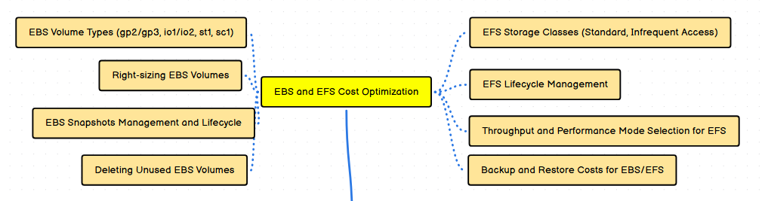
EBS and EFS Cost Optimization
- Reduce storage cost by choosing correct volume types, sizes, and lifecycle policies.
- Avoid paying for unused or over-provisioned storage.

  - EBS Volume Types
- gp3: Default choice, lower cost, configurable IOPS/throughput.
- gp2: Older general-purpose SSD, less cost-efficient than gp3.
- io1 / io2: High IOPS, expensive, for critical workloads.
- st1: Throughput-optimized HDD for large sequential data.
- sc1: Cold HDD, lowest cost for infrequent access.
  - Right-Sizing EBS Volumes
- Allocate only required storage and IOPS.
- Reduce volume size if utilization is low.
- Move from gp2 to gp3 to save cost.
  - EBS Snapshots Management and Lifecycle
- Snapshots are incremental but still consume storage.
- Delete obsolete snapshots regularly.
- Automate retention using lifecycle policies.

  - Deleting Unused EBS Volumes
- Detached volumes continue to incur charges.
- Regularly audit and delete unused volumes.
- Use tags to identify active vs unused volumes.
  - EFS Storage Classes
- Standard: Frequent access, higher cost.
- Infrequent Access (IA): Lower cost, retrieval fee applies.
  - EFS Lifecycle Management
- Automatically move files to IA after inactivity.
- Reduces storage cost for rarely accessed data.
- Best for shared file systems and logs.
  - Throughput and Performance Mode Selection for EFS
- Choose Bursting for spiky workloads.
- Use Provisioned throughput only if needed.
- Higher performance modes increase cost.
  - Backup and Restore Costs for EBS / EFS
- AWS Backup and snapshots incur storage charges.
- Restore operations may add data transfer cost.
- Define minimal but sufficient retention policies.

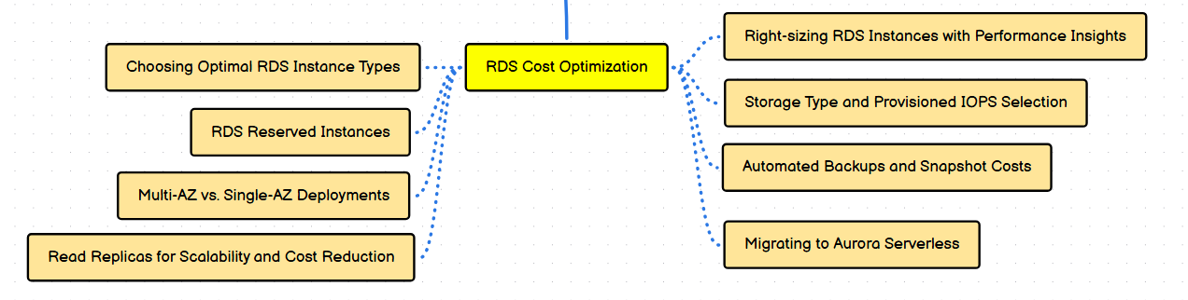
RDS Cost Optimization
- Reduce database costs by right-sizing, choosing proper storage, and optimizing availability.
- Balance cost with performance, durability, and availability needs.
  - Choosing Optimal RDS Instance Types
- Select instance class based on CPU, memory, and workload type.
- Avoid over-provisioning for low or steady workloads.
- Monitor usage before scaling up.
  - RDS Reserved Instances
- Provide significant discounts for long-term usage.
- Best for predictable and steady database workloads.
- Available as 1-year or 3-year commitments.

  - Multi-AZ vs Single-AZ Deployments
- Multi-AZ: Higher availability, higher cost.
- Single-AZ: Lower cost, suitable for dev/test.
- Choose based on business criticality.
  - Read Replicas for Scalability and Cost Reduction
- Offload read traffic from primary DB.
- Reduce need to scale up primary instance.
- Cost-effective for read-heavy applications.

  - Right-Sizing RDS with Performance Insights
- Analyze CPU, memory, and query performance.
- Identify over-sized instances.
- Scale down safely based on actual usage.
  - Storage Type and Provisioned IOPS Selection
- General Purpose (gp3) for most workloads.
- Provisioned IOPS only for high-performance needs.
- Avoid over-allocating IOPS.
  - Automated Backups and Snapshot Costs
- Backups consume storage and incur cost.
- Retain only necessary backup periods.
- Delete manual snapshots no longer required.
  - Migrating to Aurora Serverless
- Automatically scales capacity based on demand.
- Pay only for actual database usage.
- Best for unpredictable or variable workloads.

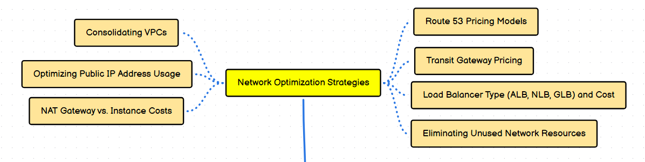
Network Optimization Strategies
- Reduce networking costs by simplifying architecture and minimizing data transfer.
- Regularly audit network components for unused or over-provisioned resources.
  - Consolidating VPCs
- Fewer VPCs reduce routing, peering, and management overhead.
- Simplifies security and connectivity.
- Lowers costs for Transit Gateway and inter-VPC traffic.
  - Optimizing Public IP Address Usage
- Public IPv4 addresses incur charges.
- Release unused Elastic IPs.
- Prefer private IPs with NAT or ALB when possible.
  - NAT Gateway vs NAT Instance Costs
- NAT Gateway: Managed, scalable, higher cost per GB.
- NAT Instance: Cheaper for low traffic, requires maintenance.
- Choose based on traffic volume and operational overhead.
  - Route 53 Pricing Models
- Charged per hosted zone, DNS queries, and health checks.
- Latency-based and geolocation routing may increase query cost.
- Use only required routing policies.

  - Transit Gateway Pricing
- Charged per attachment and per GB of data processed.
- Consolidates VPC connectivity but can be expensive.
- Evaluate alternatives like VPC peering for simple setups.
  - Load Balancer Types and Cost
- ALB: Layer 7, cost based on LCU usage.
- NLB: Layer 4, higher performance, per-hour and LCU cost.
- GLB: For security appliances, additional processing cost.
  - Eliminating Unused Network Resources
- Remove idle load balancers, unused VPC endpoints, and old gateways.
- Delete unattached ENIs and unused VPN connections.
- Regular audits prevent silent cost leaks.

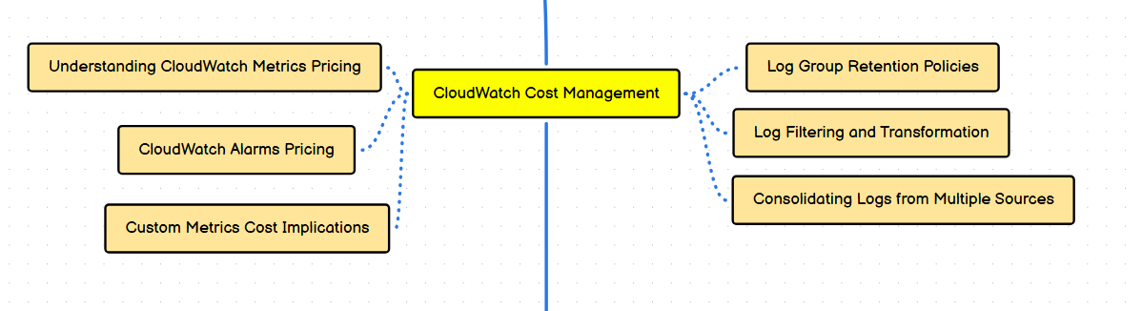
CloudWatch Cost Management
- Control monitoring costs by managing metrics, alarms, and log volume.
- Most CloudWatch costs come from custom metrics, logs, and alarms.
  - Understanding CloudWatch Metrics Pricing
- Basic AWS service metrics are free.
- Custom metrics are charged per metric per month.
- High-resolution metrics cost more.

  - CloudWatch Alarms Pricing
- Charged per alarm per month.
- Composite alarms cost more than standard alarms.
- Remove unused alarms to reduce cost.
  - Custom Metrics Cost Implications
- Each custom metric increases monthly cost.
- High-cardinality metrics can become expensive.
- Create metrics only when operationally required.
  - Log Group Retention Policies
- Logs are charged per GB ingested and stored.
- Set retention periods to auto-delete old logs.
- Avoid infinite retention unless mandatory.
  - Log Filtering and Transformation
- Filter unnecessary logs at source.
- Use metric filters selectively.
- Reduces ingestion and storage costs.
  - Consolidating Logs from Multiple Sources
- Centralize logs to reduce duplication.
- Avoid sending the same logs to multiple destinations.
- Improves visibility while controlling cost.

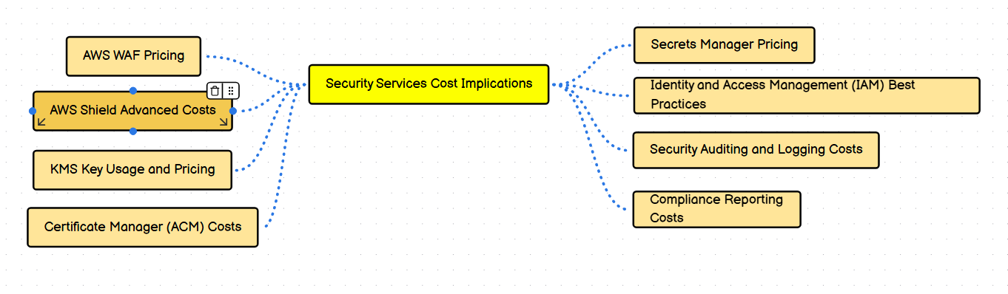

Security Services Cost Implications
- Security improves protection but adds recurring and usage-based costs.
- Optimize by enabling only required services and tuning usage.
  - AWS WAF Pricing
- Charged per Web ACL, rules, and number of requests.
- Managed rule groups add extra cost.
- Limit rules and scope to critical applications.
  - AWS Shield Advanced Costs
- Fixed monthly subscription fee.
- Protects against large-scale DDoS attacks.
- Best for internet-facing, business-critical workloads.
  - KMS Key Usage and Pricing
- Charged per customer-managed key and API requests.
- Frequent encryption/decryption increases cost.
- Reuse keys where security allows.
  - Certificate Manager (ACM) Costs
- Public SSL/TLS certificates are free.
- Private CA certificates incur charges.
- Avoid unused private certificates.

  - Secrets Manager Pricing
- Charged per secret stored and API calls.
- Frequent secret rotations increase cost.
- Use Parameter Store for low-cost, non-sensitive secrets.
  - Identity and Access Management (IAM) Best Practices
- IAM users, roles, and policies are free.
- Poor IAM design increases indirect security and audit costs.
- Use roles instead of long-term credentials.
  - Security Auditing and Logging Costs
- Services like CloudTrail and Security Hub generate logs.
- High event volume increases storage and analysis costs.
- Enable organization-wide trails and set retention.
  - Compliance Reporting Costs
- Compliance tools and audits incur operational costs.
- Automate compliance checks to reduce manual effort.
- Retain evidence only as long as required.

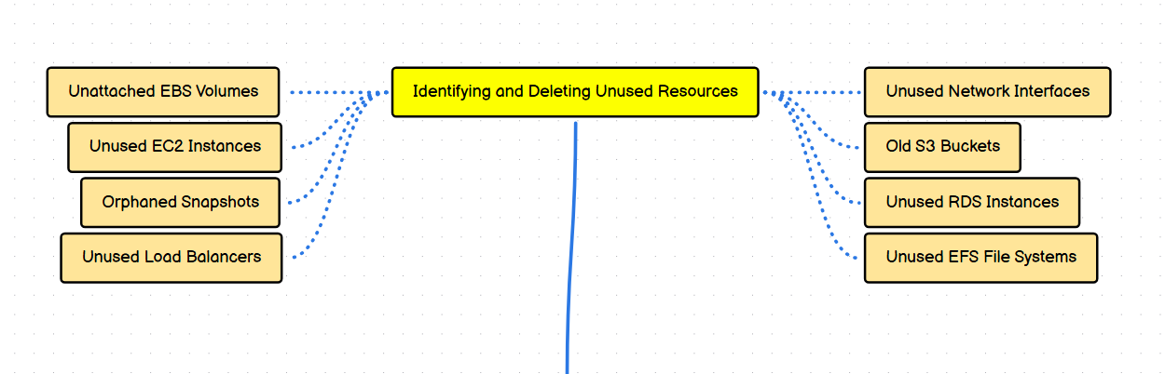
Identifying and Deleting Unused Resources
- Unused resources silently increase AWS bills.
- Regular audits are critical for cost control.
  - Unattached EBS Volumes
- Detached volumes still incur storage charges.
- Identify using EC2 console or tags.
- Delete if no longer required.
  - Unused EC2 Instances
- Stopped instances do not incur compute cost but attached storage does.
- Terminate instances not needed.
- Review low CPU utilization instances.
  - Orphaned Snapshots
- Snapshots without active volumes still cost money.
- Delete outdated or unnecessary snapshots.
- Use lifecycle policies for cleanup.
  - Unused Load Balancers
- Idle ALBs/NLBs still incur hourly charges.
- Remove load balancers with no registered targets.
- Check access logs before deletion.
  - Unused Network Interfaces
- Unattached ENIs may block instance deletion.
- Review and delete unused ENIs.
- Often created by failed or deleted services.
  - Old S3 Buckets
- Buckets with stale data incur storage cost.
- Archive or delete outdated data.
- Apply lifecycle policies.
  - Unused RDS Instances
- Idle databases incur full instance and storage costs.
- Stop or delete non-production DBs.
- Take final snapshot before deletion.
  - Unused EFS File Systems
- EFS charges per GB stored.
- Delete unused file systems.
- Verify mounts before removal.

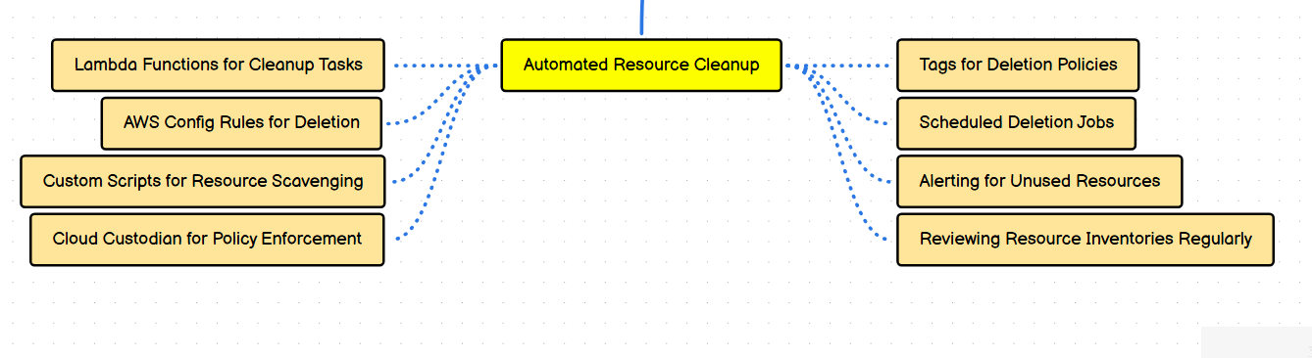
Automated Resource Clean-up
- Automates identification and removal of unused AWS resources.
- Prevents cost leakage and enforces governance.
  - Lambda Functions for Clean-up Tasks
- Use Lambda to detect and delete idle resources.
- Trigger via EventBridge schedules.
- Low-cost and serverless approach.
  - AWS Config Rules for Deletion
- Detect non-compliant resources.
- Can trigger remediation actions automatically.
- Useful for enforcing cleanup standards.
  - Custom Scripts for Resource Scavenging
- Scripts (Python/Bash) scan for unused resources.
- Run via CI/CD, Lambda, or EC2.
- Flexible but requires maintenance.
  - Cloud Custodian for Policy Enforcement
- Policy-as-code for cloud governance.
- Identifies, notifies, or deletes unused resources.
- Widely used in FinOps and security teams.

  - Tags for Deletion Policies
- Use tags like Owner, Expiry, Environment.
- Automate deletion based on tag values.
- Improves accountability.
  - Scheduled Deletion Jobs
- Run cleanup jobs during off-hours.
- Use EventBridge or cron-based automation.
- Reduces manual intervention.
  - Alerting for Unused Resources
- Notify owners before deletion.
- Use SNS or email alerts.
- Prevents accidental data loss.
  - Reviewing Resource Inventories Regularly
- Periodic audits using AWS Resource Explorer or Config.
- Validates automation accuracy.
- Ensures compliance and cost efficiency.

